MEDIA CONTACT:
Pierre Borg
Marketing Executive
Oualie Beach Resort
P: 869-469-9735 / E: pierre.borg@oualiebeach.com For Immediate Release

CARIBBEAN TOURISM ORGANIZATION RECERTIFIES OUALIE BEACH RESORT UNDER HOSPITALITY ASSURED PROGRAM
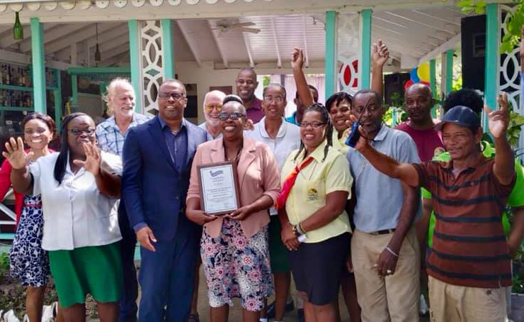
On January 14th, 2020 – Oualie Beach Resort is pleased to announce that it has been recertified once again by the Caribbean Tourism Organization’s Hospitality Assured Program.
The goal of the Hospitality Assured Program is to promote quality and service excellence throughout the tourism industry in the Caribbean region. To be Hospitality Assured, a hotel must demonstrate a proven commitment to outstanding customer service, staff morale, and responsible business practices.
Oualie Beach Resort is one of only three hotels on the island of Nevis to be Hospitality Assured. Premier Mark Brantley was in attendance today to celebrate this achievement: “What a joy today to celebrate with the management and staff of Oualie Beach Resort the recertification of that iconic property under the Hospitality Assured Program through the Caribbean Tourism Organization (CTO). This designation gives Oualie Beach Resort the stamp of international approval as a Resort where the finest service is given. I commend the Yearwood family, the General Manager Faith Bertie and the entire team at Oualie Beach Resort for this signal achievement.”

For more information or reservations, call +1(869) 469-9735, email reservations@oualiebeach.com, visit www.oualiebeach.com or follow the property on Facebook, for special deals.

