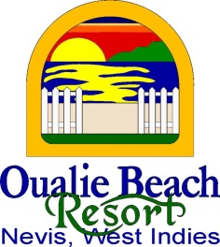
MEDIA CONTACT:
Pierre Borg
Marketing Executive
Oualie Beach Resort
P: 869-469-9735 / E: pierre.borg@oualiebeach.com For Immediate Release

OUALIE BEACH RESORT DONATES TO ESSENCE OF HOPE BREAST CANCER FOUNDATION

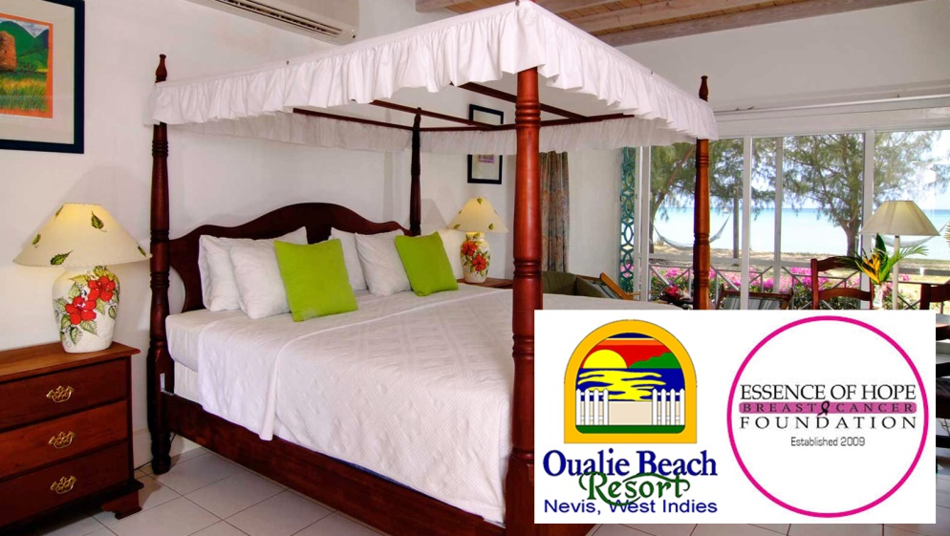
On June 25th 2019 – Oualie Beach Resort donates to Essence of Hope Breast Cancer Foundation.
"The Essence of Hope Breast Cancer Foundation is blessed and excited to be celebrating our 10th Anniversary during 2019. Launched in July 2009, Essence of Hope is a non-profit organisation geared towards ensuring women (and nowadays even men) never have to suffer at the fate of this horrible disease—cancer. Some of our many goals involve helping women in our Federation by giving free mammograms, offering financial assistance towards post-op treatments and, in some cases, assistance with the costs involved in travelling overseas to receive medical treatment.
One of our signature commemorative activities will be our Tenth Anniversary Gala Dinner, under the theme “A Decade of Helping to Save Lives,” slated for Saturday July 27, 2019 at 7:00 p.m. at the St. Kitts Marriott Resort Ballroom. Our featured speaker will be Mrs Basia Powell, a media personality and international food and travel blogger, based in Atlanta, Georgia. Trinidadian by birth, Mrs Powell is also a breast cancer survivor. She is the co-owner of Basia TV and wife of former West Indies/international cricketer/athlete, Ricardo Powell."
Oualie Beach Resort is proud to donate a two night stay as a giveaway for gala patrons for a value of US$630.

For more information or reservations, call +1(869) 469-9735, email reservations@oualiebeach.com, visit www.oualiebeach.com or follow the property on Facebook, for special deals.

